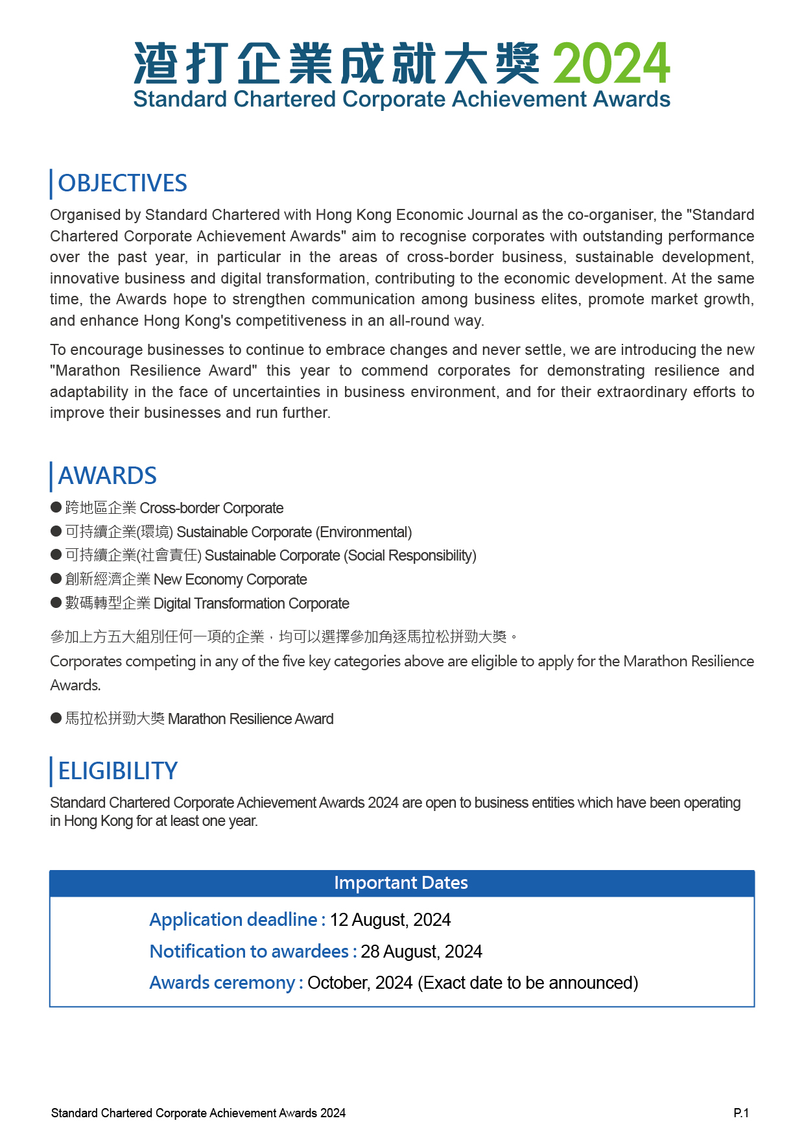
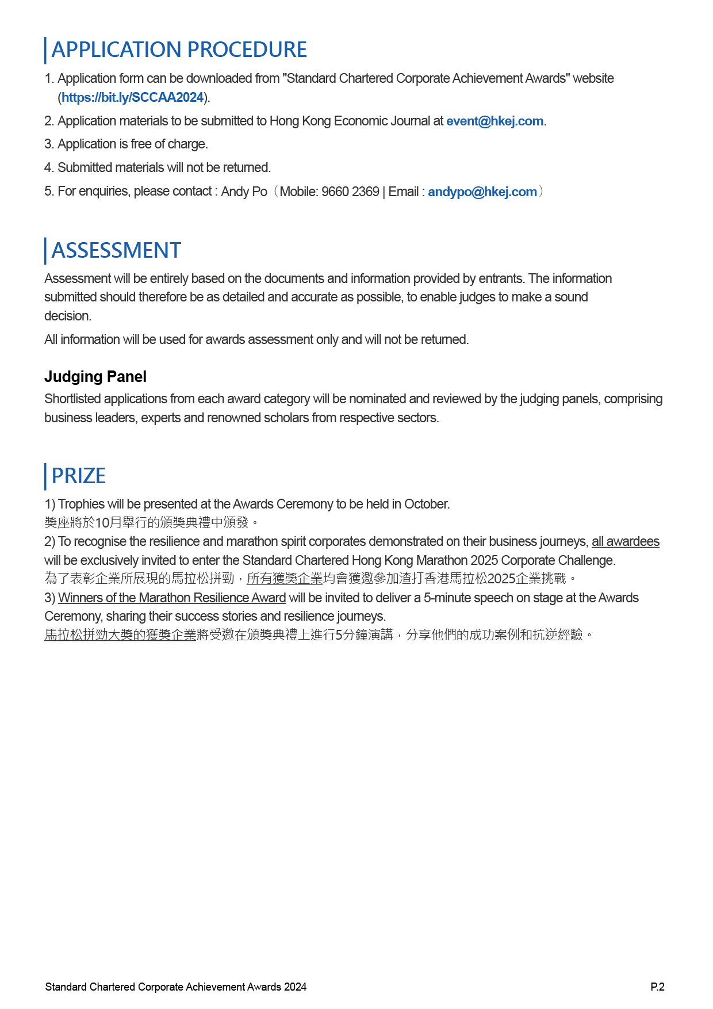
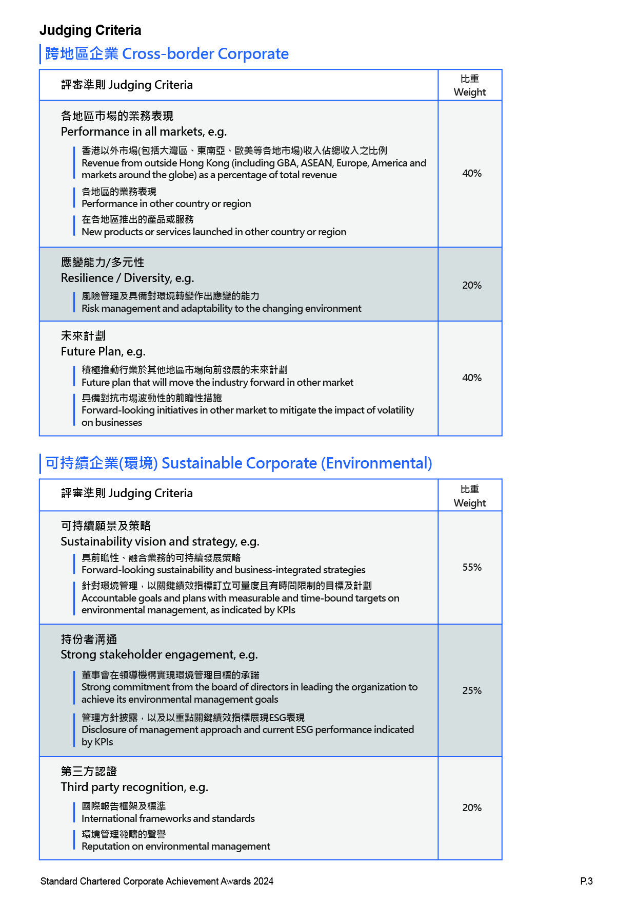
馬拉松拼勁大獎 Marathon Resilience Award
評審準則 Judging Criteria

40%
可持續性 Sustainability, e.g.
有效應對未來的挑戰
Positioned to maintain its resilience and continue thriving in the face of future challenges

30%
啟發同業 Inspirational, e.g.
對行業的正面影響，企業的拼勁故事為其他企業甚至整個行業帶來啓發
Positive influence on the industry, how the corporate's resilience journey has inspired or influenced other businesses or industry peers

30%
評審準則 Judging Criteria
數碼轉型計劃
Plan of Digital Transformation, e.g.
高創新性的數碼轉型計劃迎合市場趨勢
Demonstration of project innovativeness, catering to market trend
有清晰的願景及發展策略 Clear vision, objective and illustration of output, outcome and impact

30%
執行 Execution, e.g.
有效的數碼轉型執行計劃
Effective operational model and work plan
穩健的企業管治及管理
Sound corporate governance and management

30%
表現 Performance, e.g.
在執行數碼轉型後產品或服務有相對市場優勢
After the execution of digital transformation, the corporate have the relative market advantage of the product or service
營利或營利增長（%）
Revenue or revenue growth(%)

40%
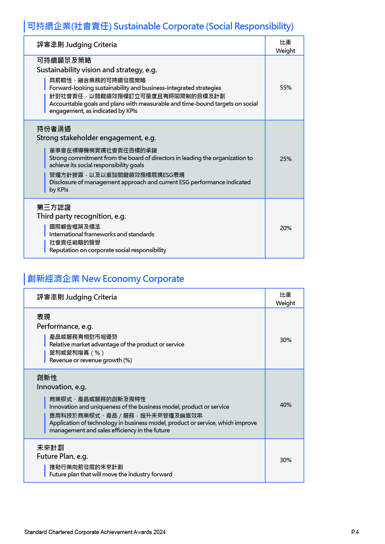
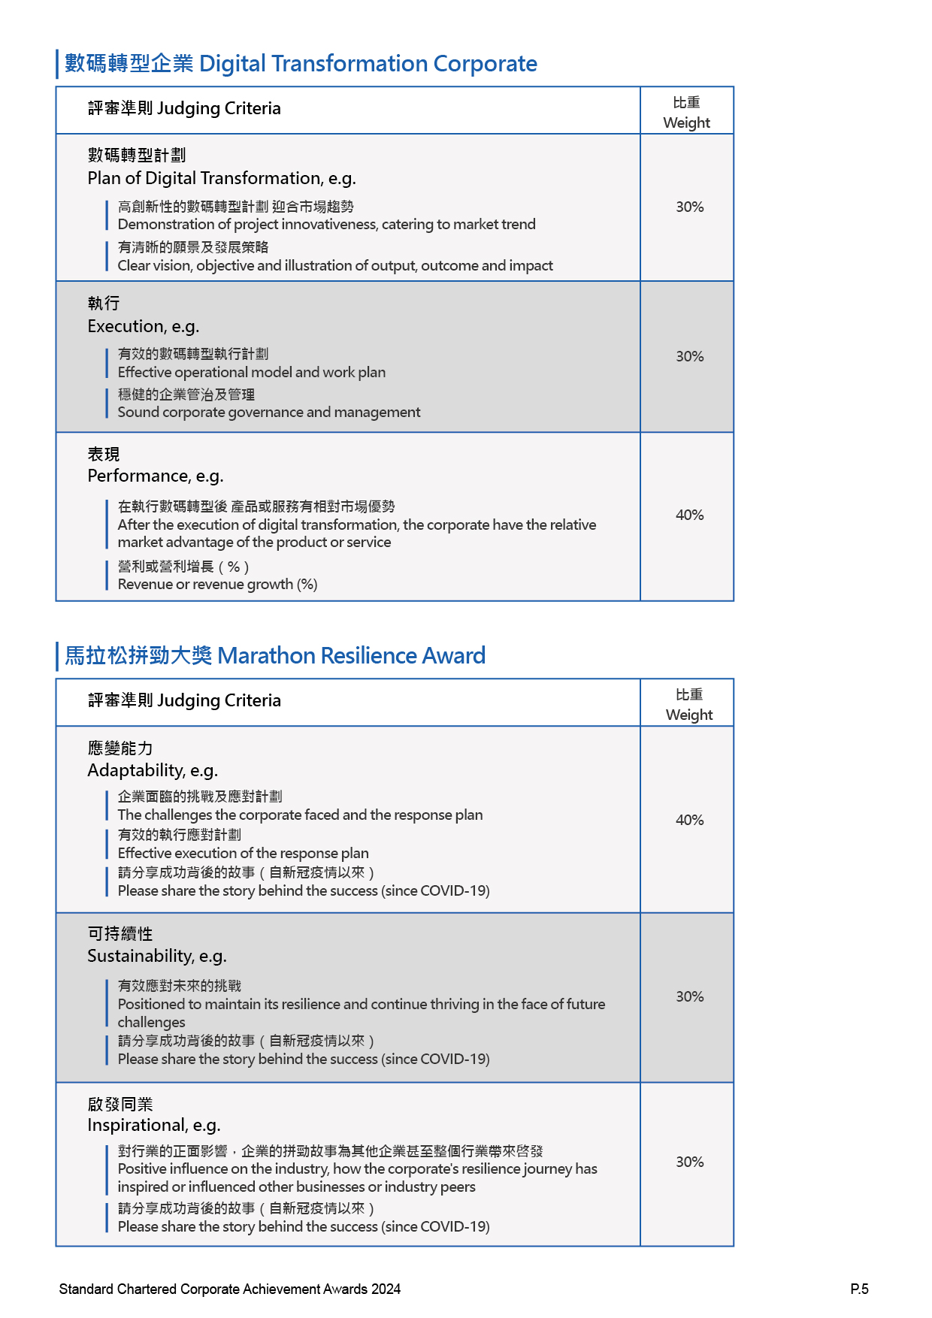
APPLICATION FORM (please fill in the form in English)

P.6
Standard Chartered Corporate Achievement Awards 2024

PART 1 – AWARD CATEGORY APPLIED (Can choose more than one option)
☐ Cross-border Corporate 跨地區企業
☐ Sustainable Corporate (Environmental) 可持續企業(環境)
☐ Sustainable Corporate (Social Responsibility) 可持續企業(社會責任)
☐ New Economy Corporate 創新經濟企業
☐ Digital Transformation Corporate 數碼轉型企業
參加上方五大組別任何一項的企業，均可以選擇參加角逐馬拉松拼勁大獎
Corporates competing in any of the five key categories above are eligible to apply for the Marathon Resilience Awards
☐ Marathon Resilience Award 馬拉松拼勁大獎

☐ 領袖獎 - 各類別領袖獎参加資格︰企業在上一財政年度的 ☐傑出獎
營業額須不少於20億美元。 or Outstanding Award
Leadership Award - Eligibility: Corporates that have
attained a minimum turnover of US$2 billion in the last financial year.

PART 2 – ENTRANTS INFORMATION
Full company name (English)
Full company name (Chinese)
Company name in Short form for future publicity use (English and Chinese)
Headquarter region
Contact Person
Name
Title
Contact number
Email
Company Background (Max 300 words)
Standard Chartered Corporate Achievement Awards 2024
PART 3 – ENTRANTS INFORMATION
- Performance illustration on ‘Cross-border Corporate’ (Max 1000 words in total):
Please refer to the judging criteria. Respond in English only.

Details for All market performance (40%):
Details for Resilience / Diversity (20%):
Details for Future Plan (40%):

P.7
Standard Chartered Corporate Achievement Awards 2024
- Performance illustration on ‘Sustainable Corporate (Environmental)’ (Max 1000 words in total)
Please refer to the judging criteria. Respond in English only.
Standard Chartered Corporate Achievement Awards 2024
Details for Sustainability vision and strategy (55%):
Details for Strong stakeholder engagement (25%):
Details for Third party recognition (20%):

P.8

- Performance illustration on ‘Sustainable Corporate (Social Responsibility)’ (Max 1000 words in total):
Please refer to the judging criteria. Respond in English only.

P.9
Standard Chartered Corporate Achievement Awards 2024
Details for Sustainability vision and strategy (55%):
Details for Strong stakeholder engagement (25%):
Details for Third party recognition (20%):

- Performance illustration on ‘New Economy Corporate’ (Max 1000 words in total):
Please refer to the judging criteria. Respond in English only.
Standard Chartered Corporate Achievement Awards 2024
Details for Performance (30%):
Details for Innovation (40%):
Details for Future plan (30%):

P.10

- Performance illustration on ‘Digital Transformation Corporate’ (Max 1000 words in total):
Please refer to the judging criteria. Respond in English only.
Standard Chartered Corporate Achievement Awards 2024

P.11
Details for Plan of Digital Transformation (30%):
Details for Execution (30%):
Details of Performance (40%):
- Performance illustration on ‘Marathon Resilience Award’ (Max 1000 words in total):
Please refer to the judging criteria. You may choose to respond in either Chinese or English for Marathon Resilience Award.
Standard Chartered Corporate Achievement Awards 2024
Details of Adaptability (40%):
Details of Sustainability (30%):
Details of Inspirational (30%):

P.12

Remarks by judges:

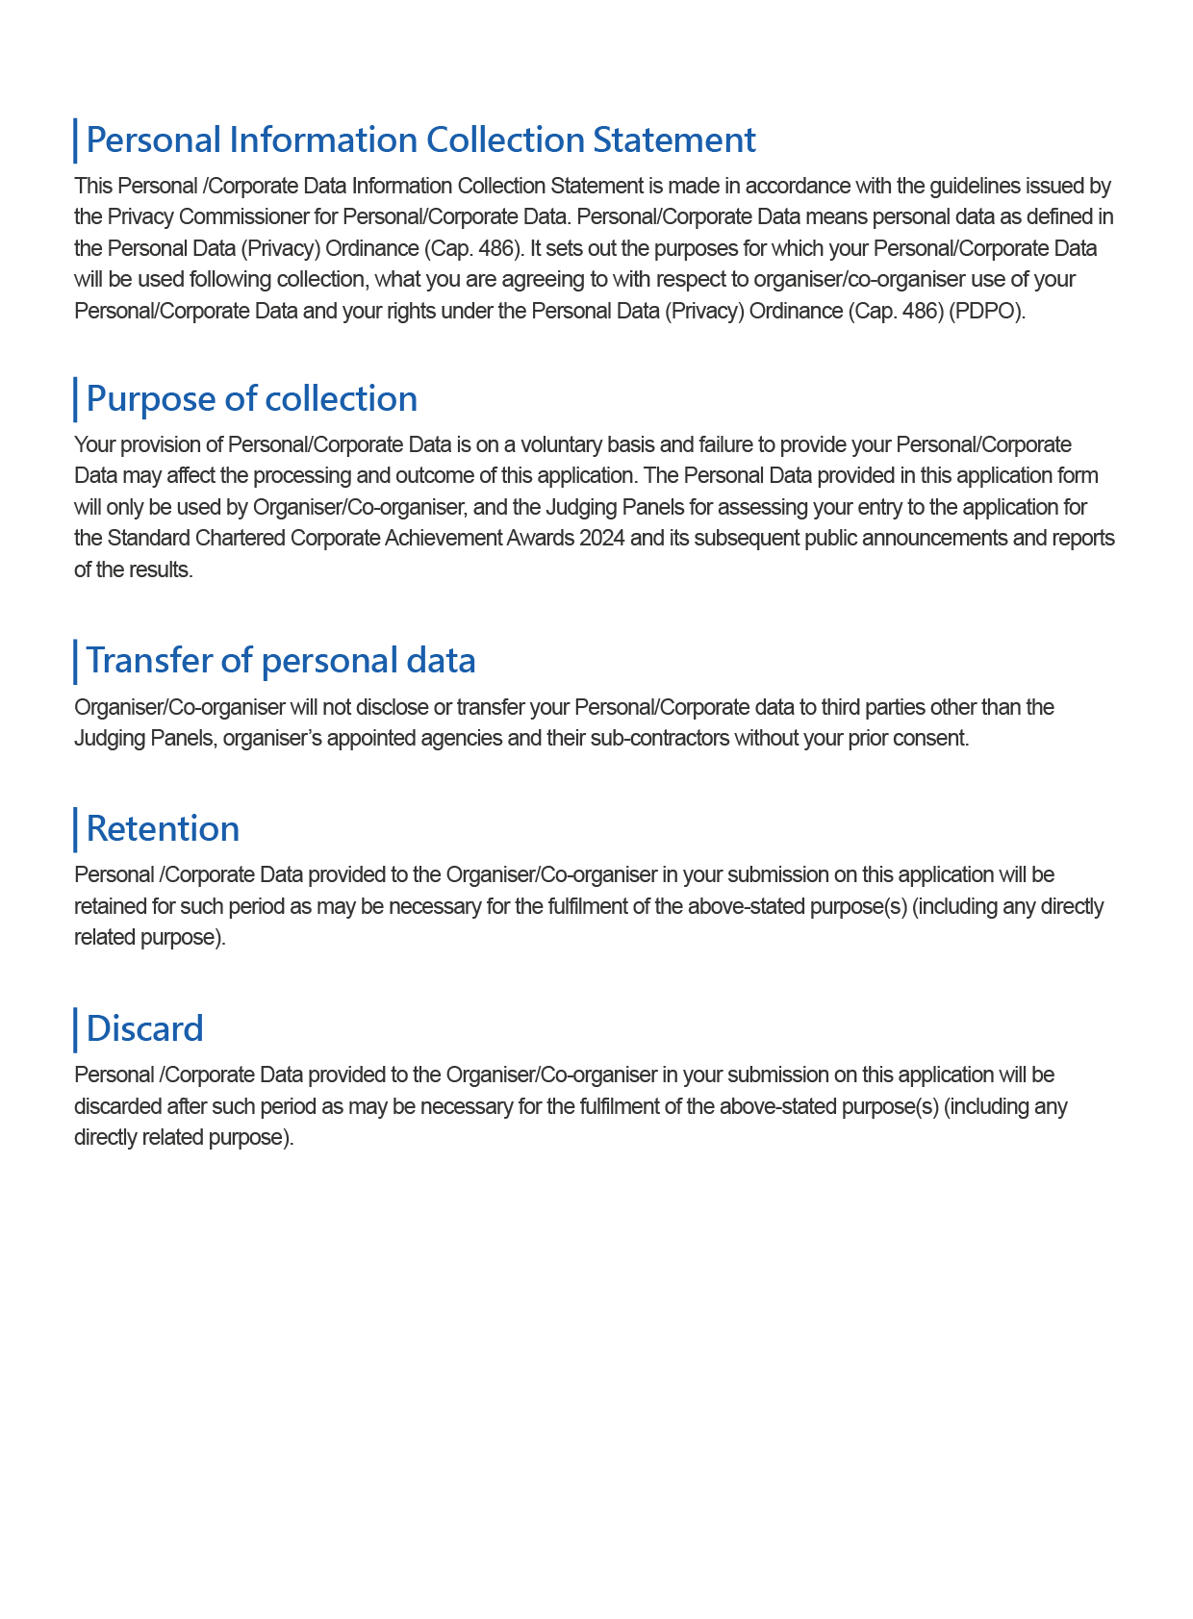

P.13
Standard Chartered Corporate Achievement Awards 2024

P.14
Standard Chartered Corporate Achievement Awards 2024

